FurniMart Project Documentation

Project Overview and Goals
FurniMart is a B2B (Business-to-Business) e-commerce platform designed specifically for the furniture industry. It enables bulk ordering and state-to-state transportation of furniture products, with future scalability to support international (country-to-country) deliveries.
The platform leverages Agile methodology for iterative development and continuous improvement, ensuring faster time-to-market and adaptability to changing business needs. Users can log in as either a manufacturer or a customer. Customers can communicate specific design requirements and color customizations directly to manufacturers, receive estimated delivery times, and manage large orders efficiently.
The overarching goal is to streamline the furniture procurement process for businesses, enhance customization, and improve logistics at scale.

Project Contributors
Guider: Mr. Navjot (Technical Training Placement Cell)
Students: Jagjeet, Vihaan, Bhavesh, Jonsi, Gokul, Ravi

Business Model
FurniMart operates on a B2B model where manufacturers connect directly with business customers. The platform serves as an intermediary that facilitates communication, customization, and logistics management.
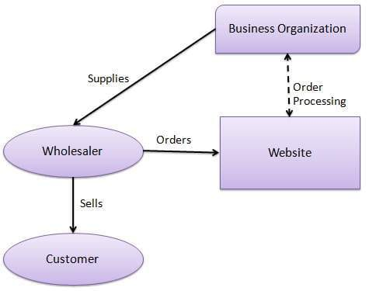
The diagram above shows the relationship between Business Organizations, Wholesalers, and Customers through the FurniMart platform.

Key Screenshots

Customer Interface
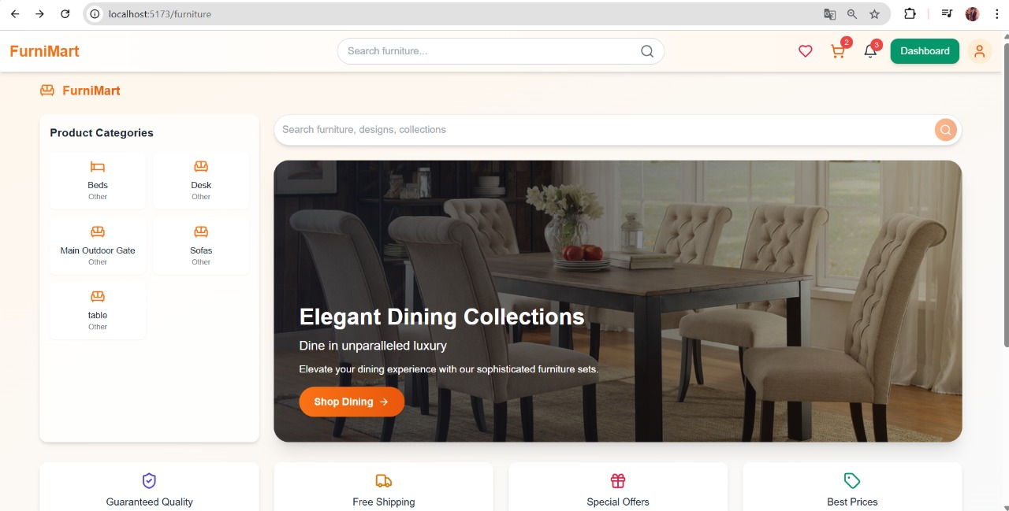

The customer interface provides an elegant, user-friendly experience with intuitive product categories, featured collections, and prominent calls-to-action. Key features include:
Clean product categorization (Beds, Desks, Outdoor Gate, Sofas, Tables)
Featured collections with high-quality images
Prominent search functionality
Cart and wishlist integration
Dashboard access for business customers

Manufacturer Dashboard
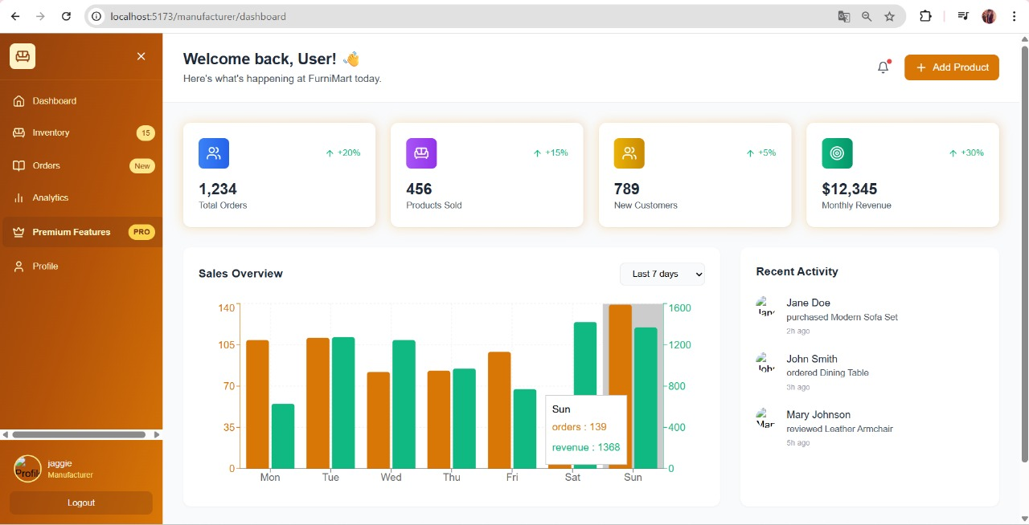

The manufacturer dashboard provides comprehensive business intelligence and order management capabilities:
Real-time metrics (1,234 Total Orders, 456 Products Sold, 789 New Customers, $12,345 Monthly Revenue)
Sales overview with daily performance metrics
Recent customer activity tracking
Inventory management (15 items in stock)
New order notifications

Login Interface
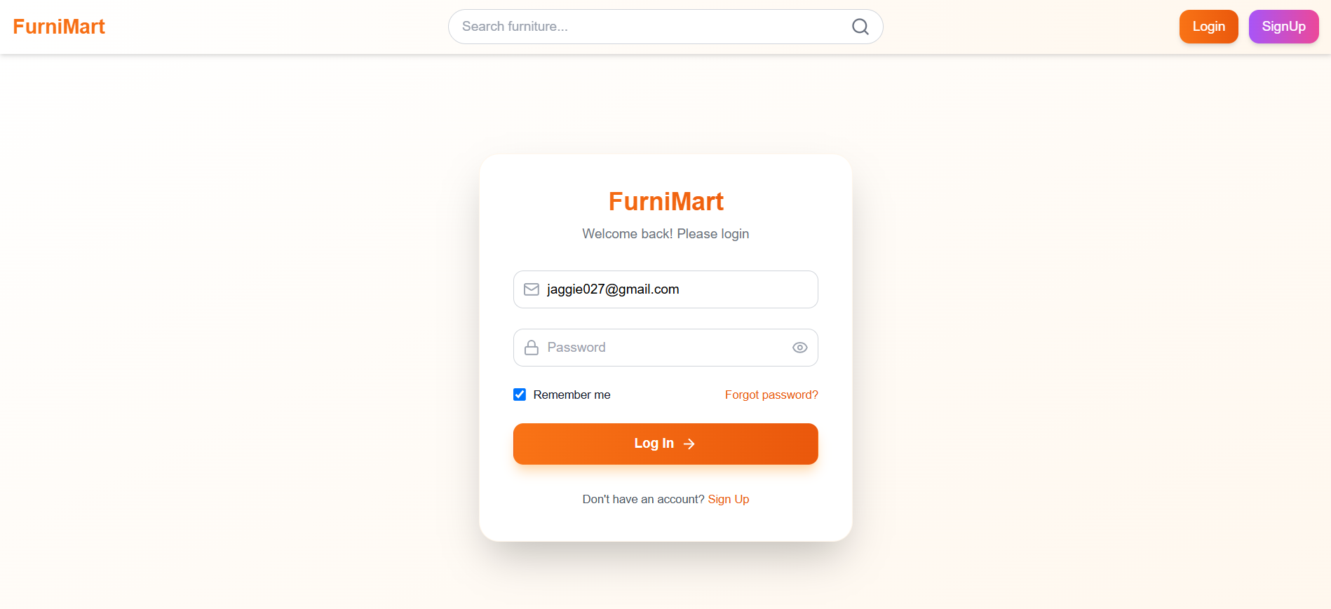
The platform features provides registration system:
Individual registration for job seekers
Organization registration for companies looking to hire talent or purchase furniture in bulk

Installation and Setup Instructions

Clone the Repository
bash git clone https://github.com/furnimart/furnimart-platform.git cd furnimart-platform

Install Dependencies
Navigate to the project directory and run:
bash npm install
or
bash yarn install

Configure Environment Variables
Create a .env file and add necessary configurations:
DB_HOST=localhost
DB_USER=root
DB_PASS=your_password
DB_NAME=furnimart_db
JWT_SECRET=your_jwt_secret
API_PORT=5173

Database Setup
Initialize and migrate the database:
bash npm run migrate or
bash yarn migrate

Start the Application
bash npm run dev
or
bash yarn dev
Access the Website
Open your browser and go to http://localhost:5173/furniture

Architecture Diagrams

High-Level Architecture
Frontend: React.js for user interface
Backend: Node.js/Express for API and business logic
Database: MySQL for persistent storage
Authentication: JWT for secure login (manufacturer and customer roles)
Cloud/Hosting: AWS for deployment and scalability
APIs: RESTful APIs for communication between frontend and backend
CI/CD: GitHub Actions for continuous integration and deployment

Tech Stack Used



Layer
Technology
Frontend
React.js
Backend
Node.js / Express
Database
MySQL
Authentication
JWT
Deployment
AWS
Version Control
Git / GitHub
UI Framework
Tailwind CSS
State Management
Redux

Features and Modules

User Authentication login types: Manufacturer and Customer
- Role-based access control
- Session management
- Password recovery

Product Catalogue
Browse and search furniture products
Advanced filtering by category, price, and material
Sorting options
Product comparison

Bulk Ordering
Place large quantity orders (B2B focus)
Volume-based discounts
Saved order templates
Recurring order scheduling

Customization
Customers can specify design and color preferences
Upload reference images
Request specialized modifications
Real-time pricing adjustments

Order Estimation
Real-time estimation of delivery time based on customization and logistics
Cost calculations including shipping
Production timeline visualization
Dependency tracking

State-to-State Transportation
Logistics module for managing inter-state deliveries
Route optimization
Carrier selection
Package tracking

Communication Module
Direct messaging between customer and manufacturer
Notification system
File sharing

Order Tracking
Real-time tracking of order status and shipment
Milestone notifications
Delivery confirmation
Issue reporting

Admin Panel
Manage users, orders, and product listings
Generate reports
Monitor system performance
Configure global settings

Future Scope
Expand to country-to-country delivery
AR/VR product visualization
AI-powered design recommendations
Carbon footprint tracking

Project Links
Production Website: furnimart.com
GitHub Repository: github.com/furnimart/furnimart-platform
Documentation: docs.furnimart.com
API Reference: api.furnimart.com/docs
Issue Tracker: github.com/furnimart/furnimart-platform/issues

User Guides

For Customers
Register/Login as a Customer
Navigate to furnimart.com
Click "Register as Organization"
Complete the registration form
Verify your email address
Log in with your credentials
Browse Products and Use Advanced Search/Filter
Use the search bar to find specific items
Filter by category using the sidebar
Sort results by price, popularity, or newest
Compare selected products
Customize Product and Submit Order
Select a product of interest
Click "Customize" button
Specify design requirements and color preferences
Upload reference images if needed
Set quantity and delivery timeframe
Review and confirm order
Track Order Status and Communicate with Manufacturer
Access "My Orders" section in dashboard
View order status and tracking information
Use messaging system to contact the manufacturer
Receive notifications on order progress

For Manufacturers
- Register/Login as a Manufacturer Navigate to furnimart.com/manufacturer
Complete the verification process
Set up your manufacturer profile
Add company information and capabilities
- View and Manage Incoming Orders Access your manufacturer dashboard
Review new and ongoing orders
Sort and filter orders by status
Generate order reports
- Respond to Customization Requests
Review customer specifications
Provide feedback on feasibility
Submit quotes and timelines
Request additional information if needed
- Update Order Status and Estimated Delivery Time
Update production milestones
Communicate delays or changes
Provide shipping information
Confirm deliveries

Contribution Guidelines
- Fork the repository and create your branch from main
- Follow the established code style guidelines
- Write clear commit messages
- Include appropriate tests with your changes
- Update documentation as needed
- Submit pull requests with detailed descriptions
- Participate in code reviews and discussions
- Respect the community code of conduct
For documentation, update or create markdown files in the /docs directory.

Changelog and Version History v1.0 (2025-05-09)
Initial release with core features
User authentication system
Product catalog with search functionality
Bulk ordering capabilities
Basic customization options
State-to-state delivery system

v1.1 (Coming Soon)
Order estimation improvements
Real-time tracking enhancements
Mobile responsive design
Performance optimizations
Enhanced admin panel
Communication module upgrade
Analytics dashboard
Integration with third-party logistics providers
Support for international (country-to-country) delivery
Advanced analytics and reporting
Machine learning for product recommendations
Augmented reality for product visualization

Acknowledgement
We sincerely thank Mr. Navjot (Technical Training Placement Cell) for his expert guidance and support throughout the project. Special thanks to team members Jagjeet, Bhavesh, Vihaan, Jonsi, Gokul, and Ravi for their dedicated contributions and teamwork.

References
- Benefits of Agile Methodology for eCommerce
- Furniture eCommerce Website
- Setting Guidelines for Repository Contributors
- The Good Docs Project - Contributing Guide
- Acknowledgement Templates

This documentation provides a structured overview for FurniMart, ensuring clarity for users, contributors, and future developers. For further details or to contribute, please refer to the repository's README and contribution guidelines.

